**Pages to be completed**

* News
* Article Page
* FAQ
* About us
* Shop

**All pages (besides homepage)**

* Can you please remove all banners from all pages and replace with this layout (Page name will be the name of page e.g. Shop, News etc)



**Homepage**

* As soon as you click home, please make the big picture fill the whole screen (Please keep “THE MARKETPLACE” & the search bar in the centre)
* Can you please add a black box under the big picture/video (example below)

It scrolls across messages (Admin will edit from Admin – Settings – Homepage)

<https://luxecollectivefashion.com/collections/womens?pf_t_condition=Brand+New>



* Please ensure the Top Trending section works automatically.
* Products that are new automatically go in the New in
* Products that are on sale go in the Sale
* Products that are most popular I will choose (from admin portal)
* Please make all product boxes look like this (same for on the Shop tab too) Please make all product pictures “fit to size”

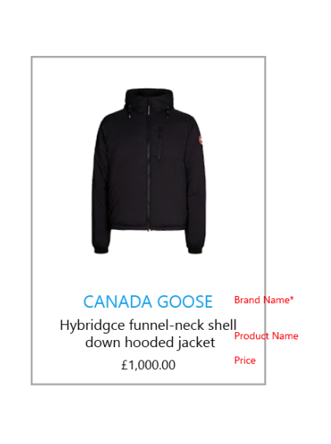

* Please make the Footer follow this format

Polices – Copyright, Disclaimer, Privacy, Return & Refund, Shipping, Terms & Conditions, Seller Agreement

**Shop**

* Please make the layout look like picture attached
* Please make the filter section look like picture attached
* Can you make the product box look like this when out of stock (It should ONLY look like this when BOTH Admin and Seller products are Out of Stock)

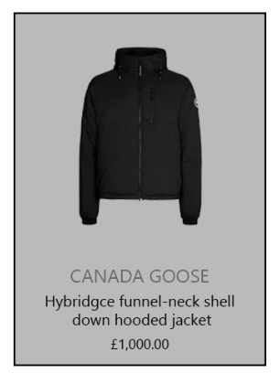

Clicking into a product

* When clicking into buy new or buy used the boxes have multiple prices in. Please can you make it say only the lowest price

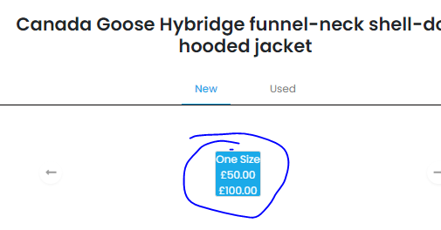

* Can you extend the “BUY NEW” & “BUY USED” boxes to cover the whole bottom line



* Size guide – Each brand has a different size guide for their products. Can we create a tab in the Admin portal that says “Size Guide” has the list of brands. Then when clicked View, it will have a list of Categories (Like the Products page with Genders in another column) then once clicked in, it will have a section for me to input the size & measurements and will show on the User side. The size guide will be linked to the brand as the product is listed and will only show that brand. **Ignore this for now**
* Compare product

Can you make the layout look like this

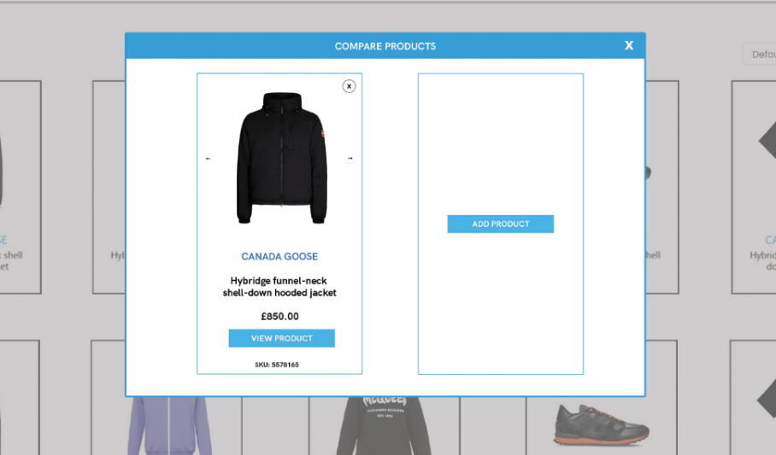

**Checkout**

* When placing an order the screen doesn’t work. Please fix

**Dashboard**

Affiliate

* Already sent doc

My Listing

* Make sure product gets removed from My Listings once sold

Item currently gets placed in both My Listing and Sold Items. We only need it in Sold Items once sold.

Selling

- Already sent a doc with all the issues

**News**

* Please see both page designs attached

**Prepaid Shipping labels**

[WooCommerce Shipping Archives - PluginHive](https://www.pluginhive.com/product-category/woocommerce-plugin/woocommerce-shipping/)